Lab 07: Nonlinear Models.

Question 1. “Simple” effects in a curvilinear model.
In our multivariable regression output from R, we get the following when we regress the DECREASE in a person’s VO2max onto the ALTITUDE at which the test was conducted (in km) and the quadratic term of ALTITUDE squared (in km²):
Coefficients:
Estimate Std. Error t value Pr(>|t|)
(Intercept) -2.2708 1.5327 -1.482 0.1415
alt_km -0.6921 1.0994 -0.630 0.5304
alt_km_sq -0.4532 0.1766 -2.567 0.0117 *
---
Signif. codes: 0 ‘***’ 0.001 ‘**’ 0.01 ‘*’ 0.05 ‘.’ 0.1 ‘ ’ 1

Residual standard error: 3.687 on 102 degrees of freedom
Multiple R-squared: 0.6491, Adjusted R-squared: 0.6422
F-statistic: 94.35 on 2 and 102 DF, p-value: < 2.2e-16

Extracting the parameter estimates, we get the following equation:
$\hat{DECREAS}E_{i}=-2.2408-0.6921\left(ALT_{i}\right)-0.4532\left(ALT_{i}^{2}\right)$
- Note that the quadratic effect of altitude is statistically significant. What is the Model A/C comparison that leads to this p-value?
  - Model A:
  - Model C:
Given this equation, we can see how the effect of altitude changes at different altitudes:
- What does the model predict the decrease will be for a person taken to:
  - 1-km?
  - 2-km?
  - What is the change from 1-km to 2-km?

- What does the model predict the decrease will be for a person taken to:
  - 4-km?
  - 5-km?
  - What is the change from 4-km to 5-km?

Notice that the effect of altitude is different at different altitudes (i.e., there is a nonlinear effect). This can be represented more easily by taking the partial derivative of the regression equation with respect to altitude:
$\hat{DECREAS}E_{i}=-2.2408-0.6921\left(ALT_{i}^{1}\right)-0.4532\left(ALT_{i}^{2}\right)$
$\frac{∆\hat{DECREAS}E_{i}}{∆ALT}=-0.6921-0.4532*\left(2\right)*\left(ALT_{i}\right)$

- Using this modified equation, what is the “simple” effect of altitude when altitude is:
  - 1-km?
  - 2-km?
  - 3-km?
  - 4-km?
  - 5-km?

Question 2. Complexity of Curvilinear models.
Next, we will analyze the same dataset but we will use a “mean-centered” version of the ALTITUDE variable. That is:
$$alt_km.c_{i}=alt_km_{i}-\overline{alt_{km}}=alt_km_{i}-3.076819$$
After calculating this mean centered version of the altitude variable, we will also compute quadratic ($alt_km.c_{i}^{2}$) and cubic versions ($al{t_km}_{i}^{3}$). Using R, we can get a quick summary of these new variables:
> summary(dat$alt_km.c)
Min. 1st Qu. Median Mean 3rd Qu. Max.
-2.49682 -0.88682 -0.07682 0.00000 1.22318 2.64318

> summary(dat$alt_km.c_sq)
Min. 1st Qu. Median Mean 3rd Qu. Max.
0.000831 0.332720 1.496172 1.995297 3.698625 6.986406

> summary(dat$alt_km.c_cu)
Min. 1st Qu. Median Mean 3rd Qu. Max.
-15.565433 -0.697437 -0.000453 -0.191532 1.830089 18.466334

Regressing the DECREASE in VO2max onto the linear, quadratic, and cubic effects of altitude yields the following output:
>summary(mod3)
Coefficients:
Estimate Std. Error t value Pr(>|t|)
(Intercept) -8.72948 0.51153 -17.065 < 2e-16 ***
alt_km.c -3.20754 0.61368 -5.227 9.33e-07 ***
alt_km.c_sq -0.44030 0.17917 -2.457 0.0157 *
alt_km.c_cu -0.06665 0.13584 -0.491 0.6248
---
Signif. codes: 0 ‘***’ 0.001 ‘**’ 0.01 ‘*’ 0.05 ‘.’ 0.1 ‘ ’ 1

Residual standard error: 3.701 on 101 degrees of freedom
Multiple R-squared: 0.6499, Adjusted R-squared: 0.6395
F-statistic: 62.51 on 3 and 101 DF, p-value: < 2.2e-16

> Anova(mod3, type="III")
Anova Table (Type III tests)

Response: decrease
Sum Sq Df F value Pr(>F)
(Intercept) 3989.0 1 291.2234 < 2.2e-16 ***
alt_km.c 374.2 1 27.3188 9.328e-07 ***
alt_km.c_sq 82.7 1 6.0391 0.0157 *
alt_km.c_cu 3.3 1 0.2407 0.6248
Residuals 1383.4 101

Use the output to answer the following question?
- Is the Omnibus F test (of all of the predictors as a set) statistically significant? (Assume that α = 0.05)?

- Is the cubic effect of altitude (alt_km.c_cu) statistically significant? (Assume that α = 0.05)?
Let’s assume, for the moment, that we had never tested the cubic effect of ALTITUDE and stopped at the quadratic effect. This analysis would yield the following regression output from R:
>summary(mod4)
Coefficients:
Estimate Std. Error t value Pr(>|t|)
(Intercept) -8.6909 0.5036 -17.258 <2e-16 ***
alt_km.c -3.4811 0.2553 -13.635 <2e-16 ***
alt_km.c_sq -0.4532 0.1766 -2.567 0.0117 *
---
Signif. codes: 0 ‘***’ 0.001 ‘**’ 0.01 ‘*’ 0.05 ‘.’ 0.1 ‘ ’ 1

Residual standard error: 3.687 on 102 degrees of freedom
Multiple R-squared: 0.6491, Adjusted R-squared: 0.6422
F-statistic: 94.35 on 2 and 102 DF, p-value: < 2.2e-16

> Anova(mod4, type="III")
Anova Table (Type III tests)

Response: decrease
Sum Sq Df F value Pr(>F)
(Intercept) 4049.5 1 297.8541 < 2e-16 ***
alt_km.c 2527.6 1 185.9177 < 2e-16 ***
alt_km.c_sq 89.6 1 6.5895 0.01171 *
Residuals 1386.7 102

We can visually contrast the predictions of these two different models with the figure below:
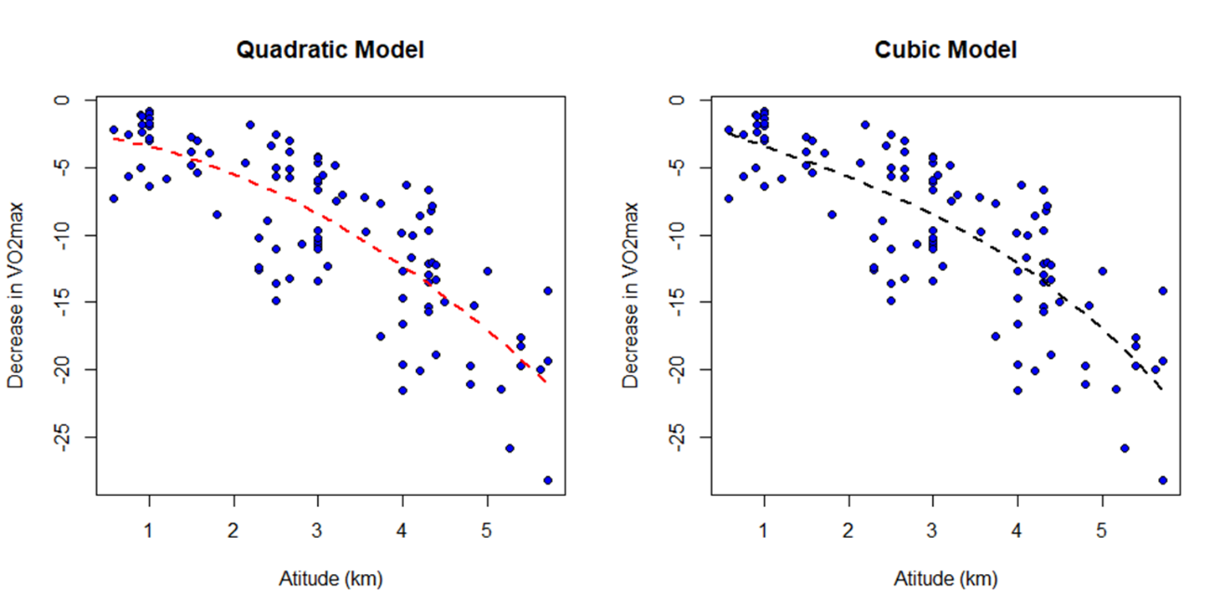
The inclusion of the cubic term does not seem to change our model’s predictions very much (hence it is not statistically significant in the cubic model). Notice, however that the Omnibus F-tests for both of these models are quite different.

- What is the Omnibus F for the Quadratic Model? Include the value of the omnibus F nad the appropriate degrees of freedom.

- What is the Omnibus F for the Cubic Model? Include the value of the omnibus F and the appropriate degrees of freedom.

- Given your knowledge of how the Omnibus F is calculated, why is the omnibus F-test different between these two models? Be sure to reference PRE (the r^2 value) for both models in your answer.

- Given that the Multiple R-Squared value shown in R is the same statistic we have been calling the proportional reduction in error, calculate the PRE for the following model comparison. Next, calculate the F-observed and the probability of obtaining an F-observed that large or larger.

  - Model A: $y_{i}= β_{0}+β_{1}\left(alt.c_{i}\right)+β_{2}\left(alt.c_{i}^{2}\right)+β_{3}\left(alt.c_{i}^{3}\right)+ϵ_{i}$
  - Model C:$y_{i}= β_{0}+β_{1}\left(alt.c_{i}\right)+β_{2}\left(alt.c_{i}^{2}\right)+ϵ_{i}$
  - Your answer:

